STEP 1 Click on Enter Records and enter the timesheet. If attributes are missing go to step 2 and follow

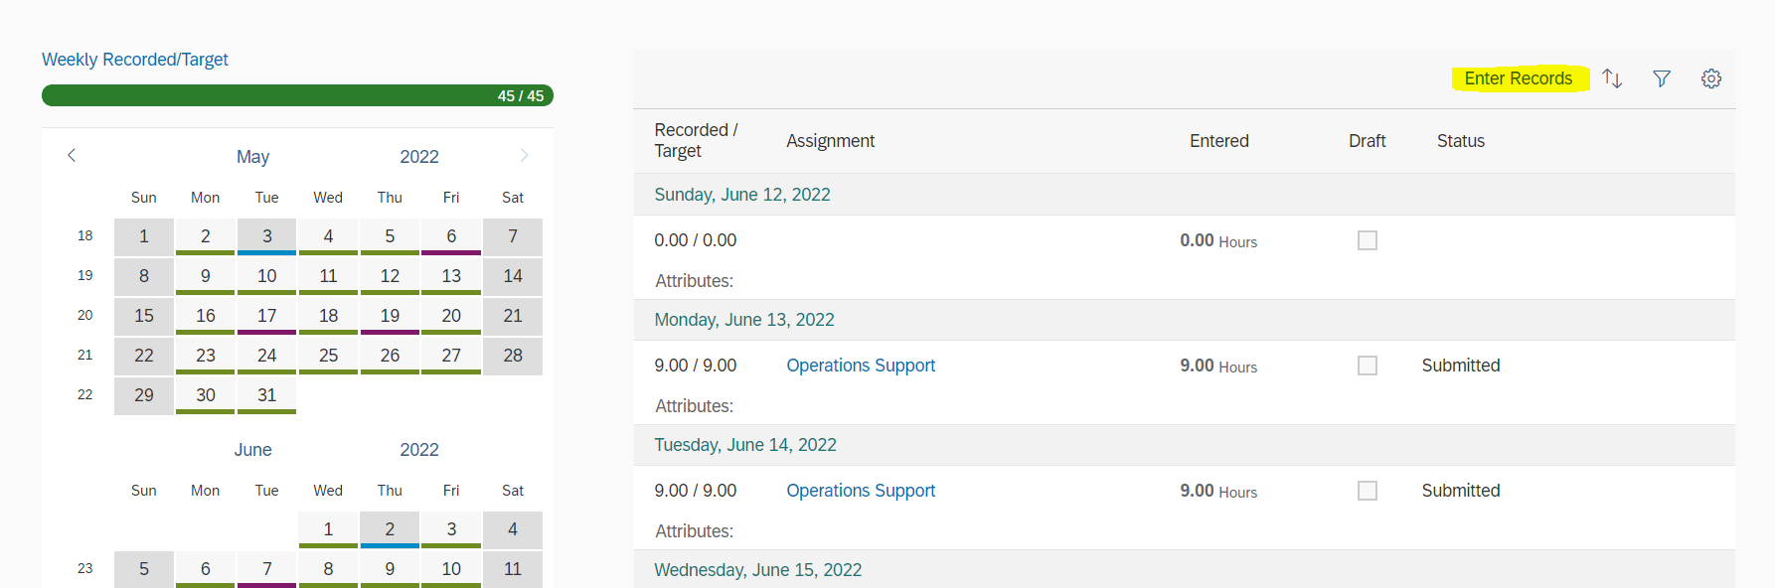

STEP 2

Click on Assignments and make sure all the attributes are selected as mentioned below

STEP 3

User can import the WBS by clicking on Import>>Worklist and select appropriate WBS code

STEP 4

Click on the above mentioned entry that appeared after selecting the work list and open it and click on edit

STEP 5

Select the required attributes as highlighted below and click on save and go back to the To do list

STEP 6

Click on to do list and then select the WBS and the hours and submit

